Predicting Automobile Prices Using Neural Networks

Divya Chopparapu
Himabindhu Karnati
Karthik Nayakam
Venkatesh Adusuru

Pompea College of Business
University of New Haven

December 03, 2025

Abstract
This capstone project investigates the determinants of used-car prices and evaluates which predictive modeling technique - linear regression, decision tree, or neural network, produces the most accurate and reliable price predictions. The business problem examined is: Which vehicle characteristics most strongly influence used-car prices, and which predictive modeling technique provides the most reliable results? This question is highly relevant for used-car dealers seeking data-driven pricing strategies.
The study uses a dataset containing 1,367 used vehicles with attributes such as age, mileage (KM), horsepower (HP), fuel type, and equipment features (ABS, AC, Tow Bar, Radio, etc.). After cleaning and preparing the data in R, three predictive models were developed. Results show that linear regression produced the strongest predictive performance, followed by decision trees, while neural networks performed the worst due to the limited dataset size. These insights, supported by Power BI dashboards, offer guidance for dealers seeking transparent, operational, and evidence-based pricing strategies.

1. Introduction
Accurately estimating the market value of used vehicles is a significant challenge for dealerships and buyers. Pricing often varies widely based on vehicle age, mileage, equipment features, brand perception, and market dynamics. Incorrect pricing decisions, whether undervaluing or overvaluing vehicles can lead to financial losses, slower inventory turnover, or reduced customer trust. Therefore, the central business problem addressed in this study is:
Which vehicle characteristics most strongly influence used-car prices, and which predictive modeling technique provides the most reliable results?
Recent advances in analytics have supported better forecasting and improved pricing transparency. Prior research emphasizes the value of machine learning in understanding market behavior. For example, studies found that vehicle age and accumulated mileage consistently emerge as dominant price predictors in online marketplaces (Zhang & Wang, 2020). Neural networks have also demonstrated strong performance in modeling nonlinear transportation data, though their accuracy heavily depends on data quality and structure (Karlaftis & Vlahogianni, 2011). Similarly, other studies showed that machine-learning models enhance pricing accuracy by identifying subtle relationships between vehicle attributes and market value (Kabir et al., 2019). Collectively, these studies highlight the importance of predictive analytics for pricing decisions and motivate the current investigation into the reliability of different models.

2. Data Collection and Preparation
The dataset used in this study contains 1,367 used cars, each described by multiple features relevant to pricing and consumer preference. Key variables include:
- Price (numeric)
- Age (years)
- KM (mileage)
- HP (horsepower)
- Fuel (Petrol/Diesel)
- Equipment indicators (ABS, AC, Tow_Bar, Radio, Metallic Rims, Power Steering, etc.)
- Color categories (Black, Blue, Silver, Grey, White, etc.)
The analysis was conducted in R using the automobile dataset consisted of 1,367 observations and 28 variables, which includes numerical variables such as Price, Age, KM, HP, Weight, and binary equipment feature such as ABS, AC, Airbags, Tow Bar, and Radio. The summary statistics indicated substantial variation in price (Min: $4,400; Max: $32,550), vehicle age (5 - 81 months), and mileage (3 - 232,942 km), suggesting strong depreciation patterns. The dataset contained no missing values, so it could be used without removal of observations. Column names were cleaned and categorical variables such as Fuel and Color were converted into factors. To prepare the data for modelling, all categorical factors were transformed into dummy variables using the dummyVars() function. Additional cleaning steps involved converting binary equipment variables into factors and creating a price-bin field for Power BI visualizations.
A 70/30 train - validation split was created to evaluate model performance fairly. The cleaned dataset was then used to build three predictive models aligned with supervised learning: linear regression, decision tree regression, and neural network regression.
Performance was evaluated using Root Mean Squared Error (RMSE), Mean Absolute Error (MAE), and coefficient of determination (R²) on the validation set. Exploratory analysis plots - correlation matrix, scatterplots, and model diagnostics - tree diagram, neural network plot, were generated to support interpretation.

3. Methodology
This project uses a predictive modeling approach to evaluate how well different algorithms estimate used-car prices. The following methods were implemented in R:

3.1 Linear Regression
A traditional statistical model that estimates price as a linear function of the predictors. It is widely used due to its interpretability and strong performance with structured numeric data. This method allows clear identification of which vehicle characteristics significantly impact price.

3.2 Decision Tree Regression
A machine-learning model that segments the dataset into homogeneous groups using recursive partitioning. Decision trees capture nonlinear relationships and interactions between features, though they may be sensitive to data size and prone to overfitting.

3.3 Neural Network Regression
A feed-forward neural network trained using backpropagation. Neural networks are powerful for capturing complex nonlinear patterns but often require large datasets and careful tuning. Given the dataset size (1,367 records), the model's performance was expected to be moderate.
All models were trained using a 70-30 partition (training vs. testing). Performance was evaluated using:
- Root Mean Squared Error (RMSE)
- Mean Absolute Error (MAE)
- R-squared (R²)
These metrics provide a comprehensive assessment of prediction accuracy and model reliability.

4. Findings and Discussion

4.1 Exploratory Analysis
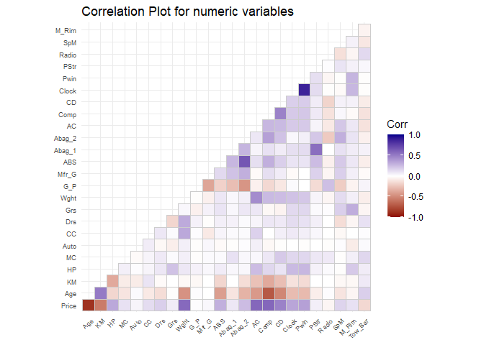
Figure 1. Correlation Matrix
Figure 1, shows strong negative relationships between Price and both Age and KM, confirming typical depreciation patterns. Horsepower and Weight show positive associations with Price, indicating that higher-performance vehicles tend to be more expensive. Binary equipment features (ABS, AC, Radio, etc.) displayed weak correlations individually but collectively contribute to price variation.
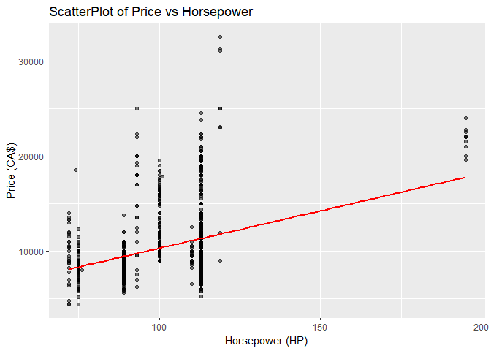
Figure 2. Scatter Plot of Price vs HP
Figure 2, reinforces this trend but shows wide variation, suggesting that performance alone is insufficient to explain price without considering other attributes. Higher HP cars show higher prices, and the fitted line reflects a positive linear relationship.

4.2 Linear Regression
The linear regression model performed strongly on validation data with:
- RMSE: 1167.974
- MAE: 908.2309
- R2: 0.9001726
Key predictors were:
- Age and KM (strong negative impact)
- HP, Weight, and Manufacturer Guarantee (positive impact)
- AC and ABS (smaller but meaningful price premiums)
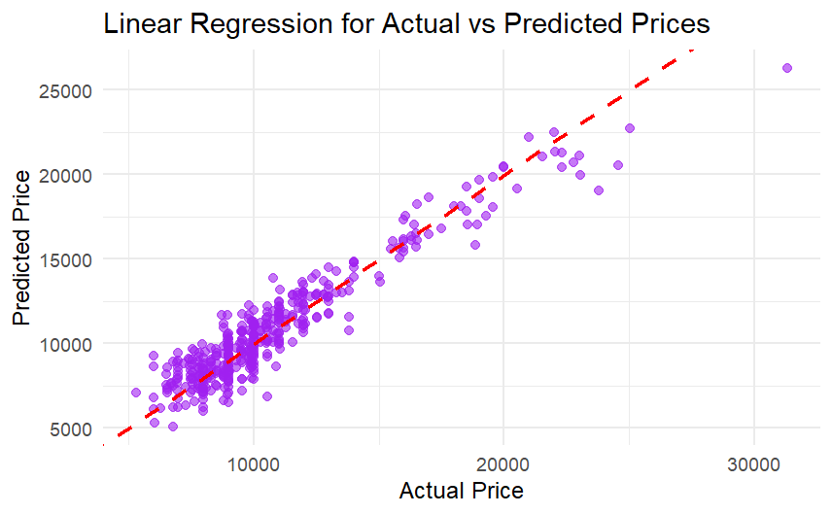
Figure 3. Linear Regression for Actual vs Predicted Prices
Figure 3, shows close alignment along the diagonal, indicating strong predictive accuracy. Regression provided both high performance and interpretable insights, making it a practical tool for pricing decisions.

4.3 Decision Tree
The regression tree produced:
- RMSE: 1409.776
- MAE: 1024.642
- R2: 0.8540996
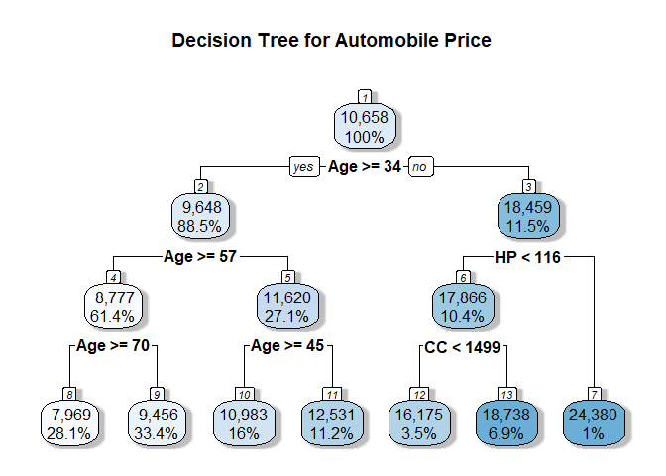
Figure 4. Decision Tree for Automobile Price
Figure 4, shows that the first splits are dominated by Age and KM, confirming that these variables drive most price variation. While less accurate than linear regression, the tree is useful for communicating simple, rule-based pricing insights (e.g., “older + high-mileage cars fall into a low-price segment”).

4.4 Neural Network
The neural network model underperformed with:
- RMSE: 3686.845
- MAE: 2563.663
- R2: NA close to 0

Neural Network Architecture for Automobile Price
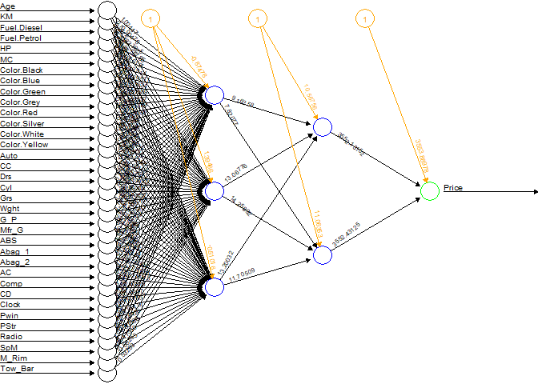
Figure 5. Neural Network Architecture for Automobile Price
Despite its flexibility, the network did not generalize well, likely due to dataset size, sensitivity to scaling, and limited hyperparameter tuning. Figure 5, shows the network architecture used. This model is not recommended for practical decision-making in this context.

4.5 Model Comparison and Implications
The predictive accuracy of each model is summarized in Table 1.

Table 1. Model Comparison Results
Model | RMSE | MAE | R²
Linear Regression | 1,168 | 908 | 0.90
Decision Tree | 1,410 | 1,025 | 0.85
Neural Network | 3,687 | 2,564 | ~ 0

Table 1 summarizes the performance of the Models. Linear regression achieved the best performance, with the lowest RMSE and highest R², suggesting a strong linear relationship between price and predictors. Linear regression clearly provides the most reliable predictions, while decision trees offer useful interpretability for managers. The neural network performed poorest, likely due to limited sample size, insufficient training depth, and model sensitivity to noise - as noted in prior literature (Karlaftis & Vlahogianni, 2011).
Overall, the R analysis shows that Age, KM, HP, Weight, and key equipment (AC, ABS) are the strongest determinants of used-car prices. For the dealership, a linear regression pricing model is the most accurate and operationally practical solution.

4.6 Power BI Dashboard Insights
The Power BI dashboards provide strong visual support for the findings:
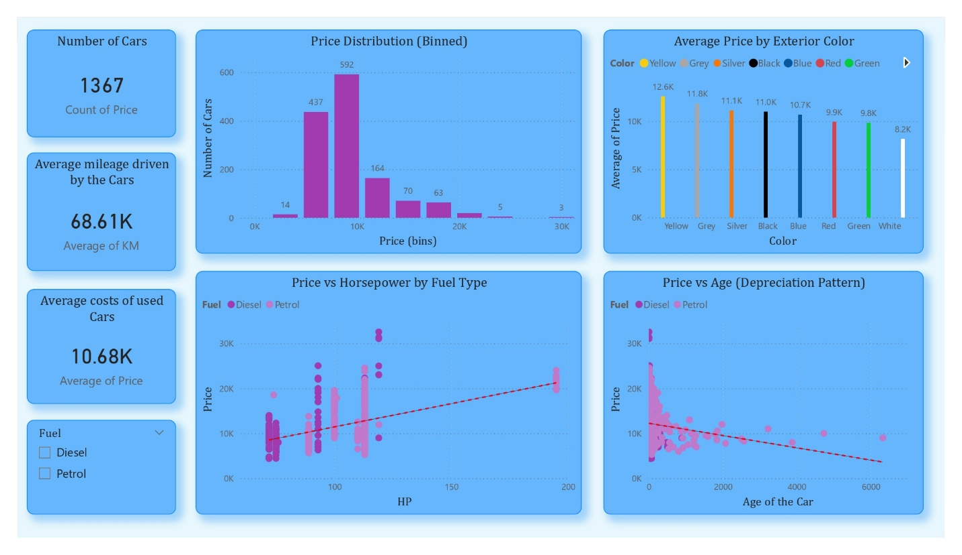
Figure 6. Page 1 - Price Overview
Figure 6, dashboard summarizes the overall pricing distribution and core vehicle characteristics:
- Average Mileage (68K km) and Average Price (~$10.7K) provide a baseline for the dataset.
- Price Distribution: Most used cars fall within the $8K–$12K range.
- Average Price by Exterior Color: Yellow, grey, and silver tend to achieve higher average prices, while white and green are lower.
- Price vs Horsepower by Fuel: Petrol and diesel categories show similar positive slopes, but diesel cars cluster slightly higher in price.
- Price vs Age: A clear depreciation curve confirms that price declines steadily as vehicle age increases.
Together, these visuals indicate that age, mileage, horsepower, and color are fundamental price differentiators.
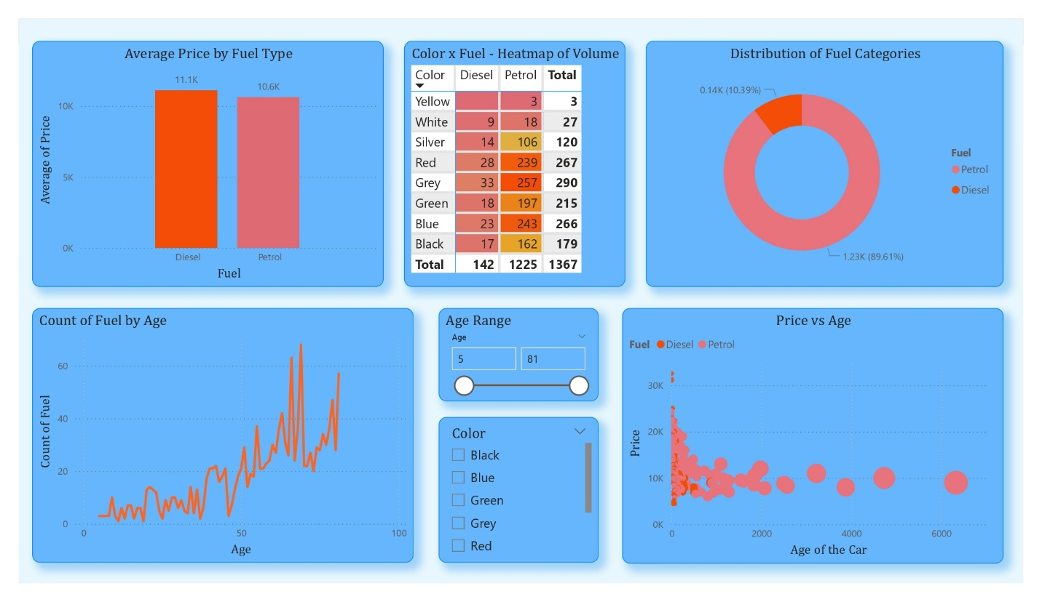
Figure 7. Page 2 - Fuel & Color Segments
Figure 7, page highlights the effect of market segmentation on pricing:
- Average Price by Fuel: Diesel vehicles show slightly higher average prices than petrol cars.
- Color × Fuel Heatmap: Grey, blue, and red are the most common colors; silver is rarer but holds mid-range pricing.
- Distribution of Fuel Categories: Petrol vehicles dominate the dataset, accounting for nearly 90% of all listings, while diesel cars represent a much smaller share.
- Fuel Count by Age: Fuel type distribution remains consistent across age, indicating no sampling bias.
- Price vs Age by Fuel: Depreciation occurs in both fuel categories, although some diesel vehicles maintain price longer.
This page demonstrates that fuel type and color influence price but not as strongly as structural variables like age and mileage.
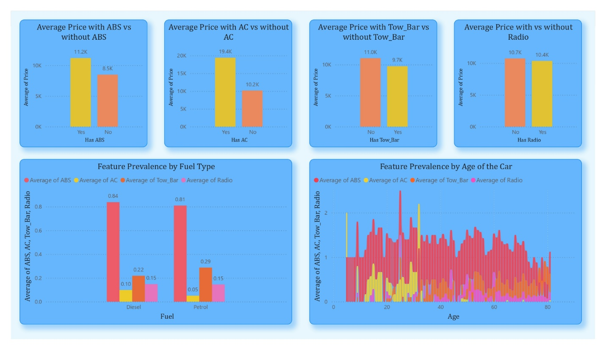
Figure 8. Page 3 - Equipment & Features
Figure 8, equipment dashboard shows how optional features align with pricing:
- ABS, AC, Tow Bar, Radio: Vehicles with these features consistently have higher average prices.
- Feature Prevalence by Fuel: Diesel vehicles show higher levels of key features such as ABS and AC than Petrol Vehicles. Radio availability remains comparable across both fuel types.
- Feature Prevalence by Age: Newer vehicles are equipped with a wider set of modern features, with ABS being the most consistently included across all ages.
These visuals reinforce that vehicle equipment significantly contributes to price, consistent with regression findings.
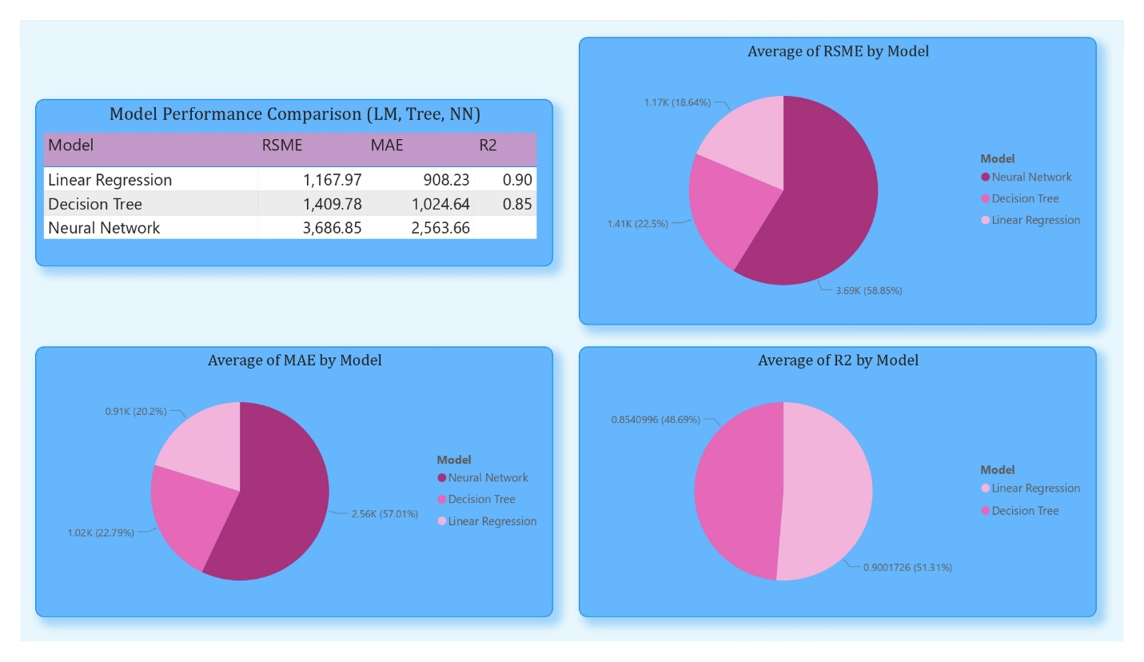
Figure 9. Page 4 - Model Summary & Comparison
Figure 9, dashboard summarizes model performance across three predictive models:
- Linear Regression: RMSE = 1,168; MAE = 908; R² = 0.90
- Decision Tree: RMSE = 1,410; MAE = 1,024; R² = 0.85
- Neural Network: RMSE = 3,687; MAE = 2,563; R² not stable
Linear regression clearly outperformed the tree and neural network, achieving the highest predictive accuracy and lowest error. This finding directly answers the second part of the business question: among the techniques tested, linear regression is the most appropriate tool for predicting used-car prices in this context.

4.7 Discussion and Business Implications
For a used-car dealership, the insights are highly actionable:
- Pricing Strategy: Age and mileage should anchor baseline pricing, with equipment features used as value-add differentiators.
- Inventory Decisions: Vehicles with ABS, AC, and enhanced safety features appear to retain value better, guiding procurement strategy.
- Model Choice: Linear regression is the recommended pricing tool due to its accuracy, interpretability, and ease of deployment.
- Operational Feasibility: Decision trees and neural networks require additional computational resources and more training data; thus, their implementation may not yield proportional benefits for a small-to-medium dealership.

5. Conclusion
This study examined which vehicle characteristics most strongly influence used-car prices and evaluated three predictive modeling techniques. Consistent with existing literature, vehicle age, mileage, horsepower, and equipment features emerged as the strongest predictors. Among the models tested, linear regression provided the most accurate and reliable predictions, outperforming both decision trees and neural networks.
The project experience demonstrated simpler models can sometimes perform better than more complex techniques when working with datasets of moderate size. A future extension of this work could explore larger datasets, brand-specific pricing, or ensemble models such as random forests and gradient boosting, which may capture nonlinearities more effectively while preserving predictive stability.

References
[1] Kabir, M., Satu, M. S., & Amin, M. R. (2019). Used car price prediction using machine learning techniques. International Journal of Advanced Computer Science and Applications, 10(8), 451–459.
[2] Karlaftis, M. G., & Vlahogianni, E. I. (2011). Statistical methods versus neural networks in transportation research: Differences, similarities and some insights. Transportation Research Part C: Emerging Technologies, 19(3), 387–399.
[3] Zhang, X., & Wang, K. (2020). Determinants of used-car prices in online marketplaces: A machine-learning approach. Journal of Retailing and Consumer Services, 54, 102029.

